**SPRINT 3**

|  |  |
| --- | --- |
| Date | 14 November 2022 |
| Team ID | PNT2022TMID31434 |
| Project Name | Smart Farmer-IoT Enabled smart Farming Application |

**Creating Mobile app using MIT app Inventor**

**SMART FARMER APPLICATION**

App Inventor + IoT can work together to help us understand, and change, our

everyday lives.

**Blocks**

**QR CODE FOR APK DOWNLOAD:**

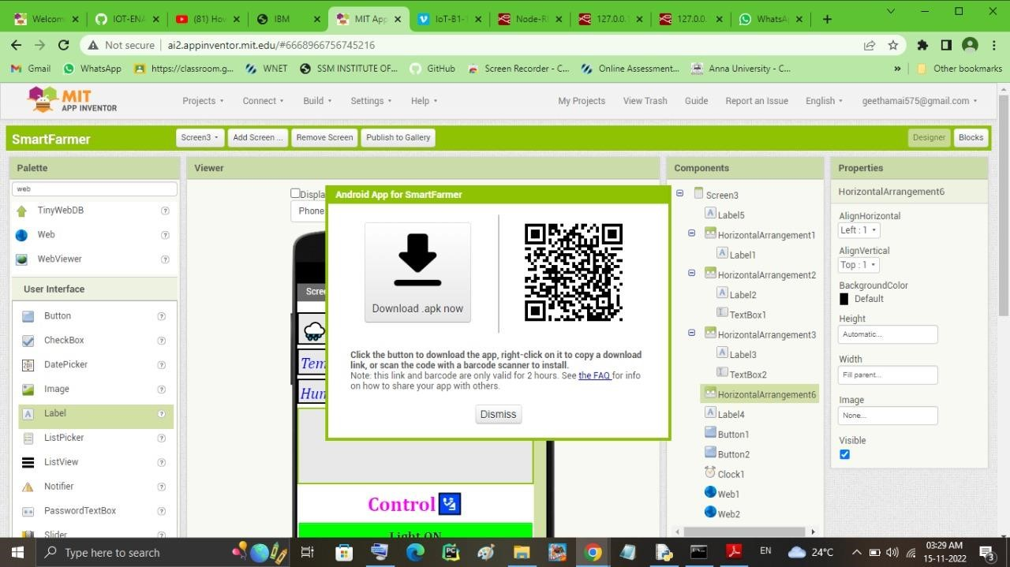

REGISTRATION AND LOGIN SCREEN :

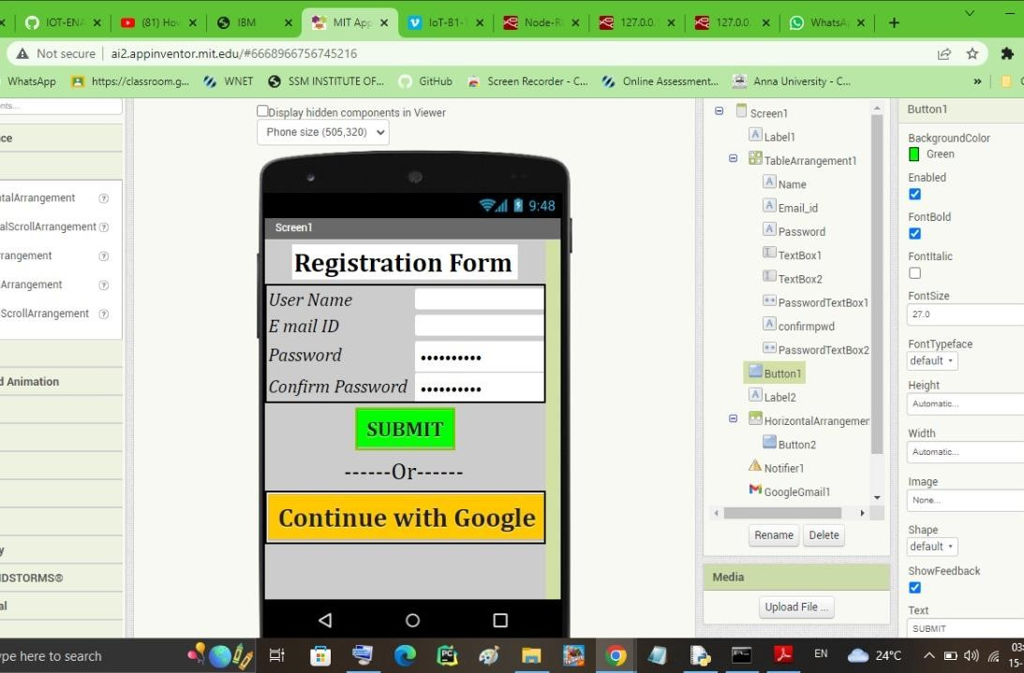

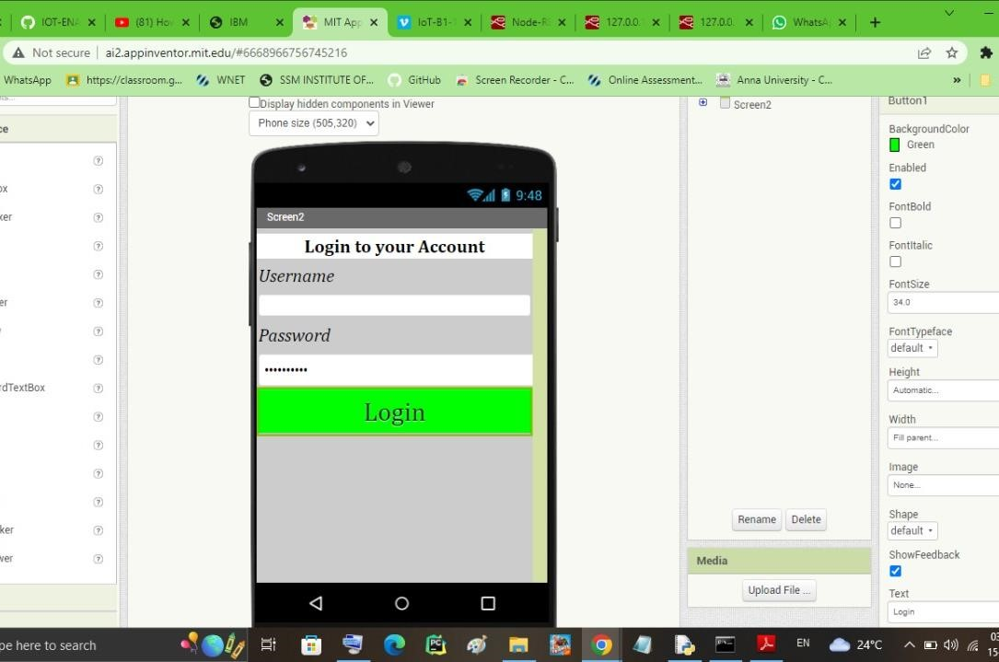

**OUTPUT SCREEN:**

